
RAMAIAH
INSTITUTE OF TECHNOLOGY
USN | 1 | M | S

(Autonomous Institute, Affiliated to VTU)
(Approved by AICTE, New Delhi & Govt. of Karnataka) Accredited by NBA & NAAC with ‘A’ Grade

SEMESTER END EXAMINATIONS – JANUARY 2018

Course & Branch | : | B.E. : Computer Science & Engineering | Semester | : | V
Subject | : | Computer Networks | Max. Marks | : | 100
Subject Code | : | CS53/CS514/CS1553 | Duration | : | 3 Hrs

Instructions to the Candidates:
- Answer one full question from each unit.

 |  | UNIT- I
1. | a) | Consider an e-commerce site that wants to keep a purchase record for each of its customers. Describe how this can be done with cookies with neat figure. | CO1 | (06)
 | b) | Suppose Alice with a Web-based e-mail account (such as Yahoo! mail or Hotmail) sends a message to Bob, who accesses his mail from his mail server using POP3. Discuss how the message gets from Alice's host to Bob's host. Be sure to list the series of application-layer protocols that are used to move the message between the two hosts. | CO1 | (04)
 | c) | Why is HTTP called as stateless protocol Explain with an example? Differentiate between the following. (i) GET and Conditional GET method (ii) HTTP and FTP. | CO1 | (10)
2. | a) | Suppose Bob joins a BitTorrent torrent, but he does not want to upload any data to any other peers (so called free-riding).  i. Bob claims that he can receive a complete copy of the file that is shared by the swarm. Is Bob’s claim possible? Why or why not?  ii. Bob further claims that he can further make his “free-riding” more efficient by using a collection of multiple computers (with distinct IP addresses) in the computer lab in his department. How can he do that? | CO1 | (06)
 | b) | Explain the services provided by DNS. Discuss the problems involved I in centralized design of DNS. | CO1 | (08)
 | c) | In the circular DHT shown below Suppose that peer 3 learns that peer 5 has left. How does peer 3 update its successor state information? Which peers are now its first and second successors? Now, suppose that a new peer 6 wants to join the DHT and it initially only knows peer 15’s IP address. What steps are taken?  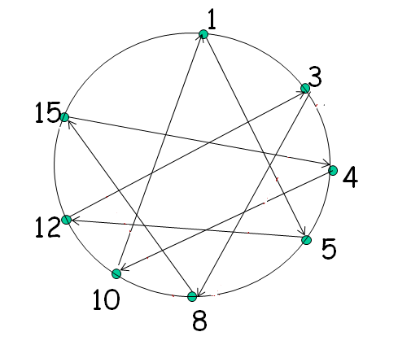 | CO1 | (06)
 |  | UNIT- II
3. | a) | Explain TCP segment structure with a neat block diagram. | CO2 | (12)
 | b) | Write the neat flow diagram for the following scenarios.  - Retransmission due to lost acknowledgement  - Cumulative acknowledgment avoing retransmission of first segment.  - Retransmitting the missing segment before the timer expires. | CO2 | (08)
4. | a) | What is meant by fairness in TCP? With an example explain how TCP connection share single bottleneck link. What are the problems in sharing? | CO2 | (06)
 | b) | Illustrate with neat figure, connection oriented multiplexing and demultiplexing | CO2 | (08)
 | c) | With a neat UDP segment structure explain all its fields. Discuss UDP checksum with an example. | CO2 | (06)
 |  | UNIT- III
5. | a) | Explain IPv4 packet format With a neat block diagram. | CO3 | (08)
 | b) | An organization is granted a block of addresses with the beginning address 14.24.74.0/24. The organization needs to have 3 subblocks of addresses to use in its three subnets: one subblock of 10 addresses, one subblock of 60 addresses, and one subblock of 120 addresses. Design the subblocks. | CO3 | (08)
 | c) | Compare and contrast link-state and distance-vector routing algorithms. | CO3 | (04)
6. | a) | Suppose that a host application needs to transmit a packet of 3500 bytes. The physical layer has MTU of 1500 bytes. The packet has an IP header of 20 bytes. Fragment the packet, and specify the ID, MF and offset fields of all fragments. | CO3 | (07)
 | b) | What is address depletion? Differentiate between subnetting and supernetting. | CO3 | (05)
 | c) | Explain OSPF routing with algorithm. | CO3 | (08)
 |  | UNIT- IV
7. | a) | With a neat figure illustrate the steps involved when a base station with common MSC decides to hand off its mobile user. | CO4 | (08)
 | b) | What is the advanced feature of 802.11? | CO4 | (06)
 | c) | What are the approaches used to solve the problem of TCP congestion control response in a wireless setting with high bit error rate. | CO4 | (06)
8. | a) | Exp Explain working of multiprotocol BGP with a neat figure. | CO4 | (10)
 | b) | Discuss GSM 2.5G cellular voice and data network architecture with a neat figure. | CO4 | (10)
 |  | UNIT- V
9. | a) | Discuss resource reservation protocol and why is this protocol required. | CO5 | (06)
 | b) | We have five packets to transmit in real time. The estimated average jitter until the time of the first packet is 0.02 ms. Following table shows the timestamps of RTP data packets indicated by the source, ti, and the arrival times of RTP packets at the receiver ai. Assume that the normalizing coefficient k is 0.2. Estimate the average jitter until every packet has arrived. What would be the possible reason(s) that ti increases at a different rate from i?  Example of source timestamps and receiver arrival times for five packets: | CO5 | (08)
  i | 1 | 1 | 1 | 1 | 1
  ai | 43 | 45 | 47 | 49 | 51
  ti | 69 | 74 | 73 | 91 | 99
 | c) | Discuss four major components of traffic conditioner and explain the operation of differentiated services with neat figure. | CO5 | (06)
10. | a) | The below figure shows four flows A, B, C and D are processed at one of the outputs of a router. For each packet, the time it arrives and its label are indicated in the figure. Specify the order of packet transmitted at this output, using the following three schedulers. All schedulers scan the flows from A.  - Priority queuing- priorities decrease from line A to line D.  - Fair queuing- if the arrival times of two packets are same, the smaller flow number is selected.  - Weighted fair queuing, where flows A, B, C, and D are given 10%, 20%, 30% and 40%, respectively, of the output capacity.  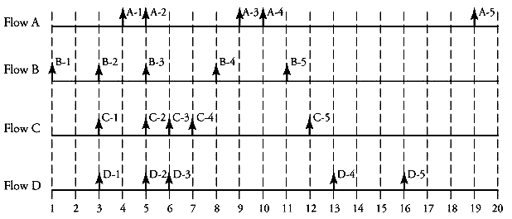 | CO5 | (06)
 | b) | What is the need of content distribution networks? Explain with an example CDN interactions with DNS. | CO5 | (08)
 | c) | Suppose that a live transmission of a compressed color video movie between two points of an IP network requires 2 hours of network use. We want to apply SCTP for this transmission. Each image of this video consists of 1,024 x 1,280 pixel blocks, and the video consists of 30 images per second. One option is to encapsulate each block of pixels in a chunk, allowing each row of a frame (image) to be formatted by one packet. Assume that each pixel block is compressed on average to 10 phrases and each phrase requires on average 5 bits. (i) Find the size of each SCTP chunk, including its header. (ii) Find the total size of each SCTP packet, including its header. | CO5 | (06)
****************

